**RESUME**

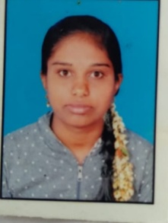

**DEVIKA R**

Email:ddevu7074@gmail.com

**Mobile No:**+91-9741141254

Objective:

To succeed an environment of growth and excellence earn a job which provides me job satisfaction and self development and help me achieve personal as well as organizational goals.

Educational Qualifications:

|  |  |  |  |
| --- | --- | --- | --- |
| **Education** | **Board** | **Year of Passing** | **Percentage** |
| SSLC | KSEEB | 2017 | 65.76% |
| PUC  (EGBA) | Govt Girls College Gundupet | 2019 | 65.66% |
| Diploma | Govt polytechnic College, Chamarajanagara | 2022 | 67.88% |

**Technical Skills:**

Basic Computer

C programming

Web design

**Work Experience**:

Fresher

**PERSONALDETAILS:**

Name **: Devika.R**

Father Name **: Rudraiah**

Date of Birth **: 15/12/2001**

Gender **: Female**

AadharNo **: 4753 2136 7103**

Languages Known **:** Kannada, English

Communication Address **:** D/o Rudraiah

Muntipura Village Baragi Post, Gundupet Taluk,

Chamarajanagara District–571111

Nationality **:** Indian

Religion **:** Hindu

**“I’m sure I will delight you with my Work”**

**Declaration:**

I hereby declare the information and facts stated above are correct and true to the best of my knowledge and belief.

Date: **Yours faithfully**

Place:

